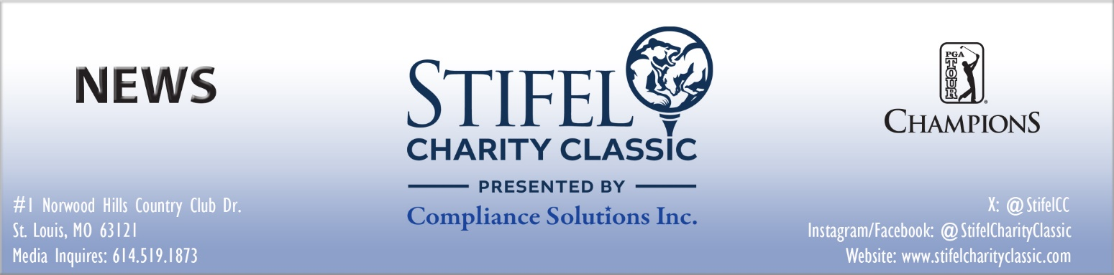

For Immediate Release
July 24, 2025
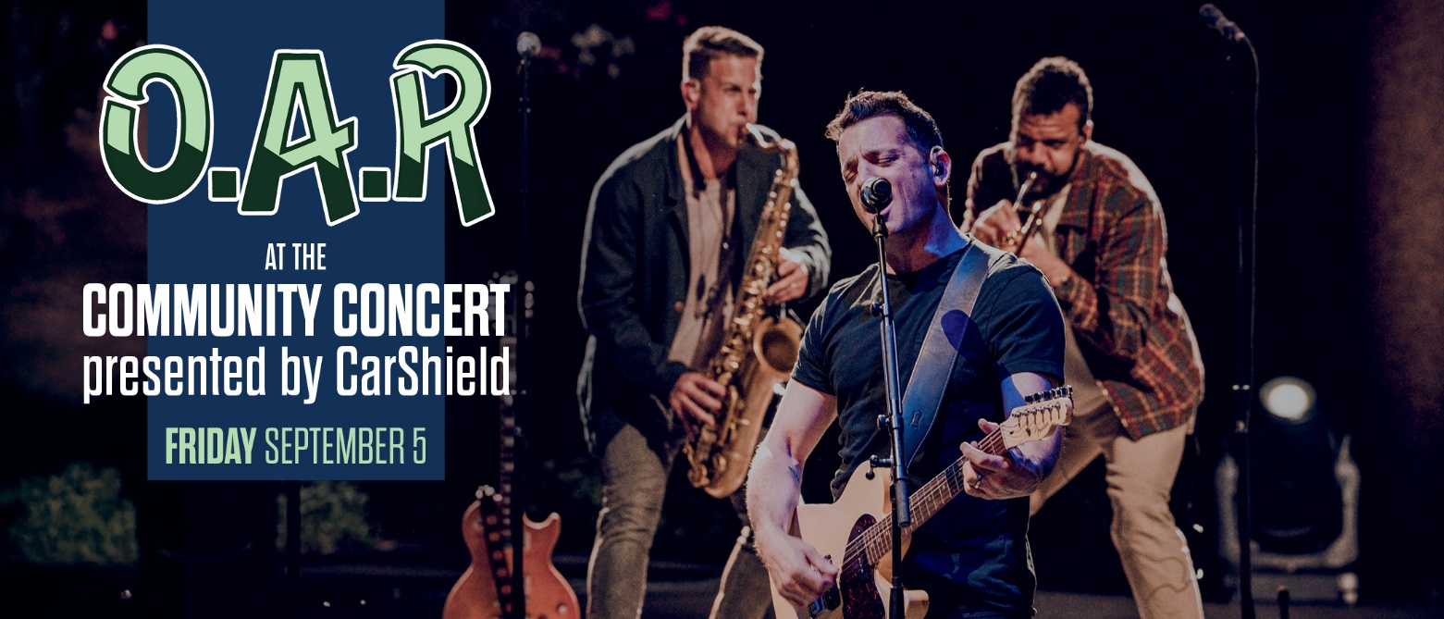

STIFEL CHARITY CLASSIC PRESENTED BY COMPLIANCE SOLUTIONS INTRODUCES COMMUNITY CONCERT PRESENTED BY CARSHIELD

Multi-platinum-selling band O.A.R headlines inaugural concert event on Friday, September 5 at Norwood Hills Country Club

ST. LOUIS (July 24, 2025) – Officials of the Stifel Charity Classic presented by Compliance Solutions announced today the details surrounding the tournament’s newest event. O.A.R at the Community Concert presented by CarShield will take place Friday evening, September 5, following the first round of tournament competition at the official PGA TOUR Champions event.

The Stifel Charity Classic Community Concert will be held on Hole No. 18 of the East Course at Norwood Hills Country Club. Access to the concert requires the purchase of a valid Friday tournament ticket, or a weekly ticket option.

Tickets are on sale for the 2025 Stifel Charity Classic presented by Compliance Solutions, taking place the week of September 1–7, 2025 at Norwood Hills Country Club. The public may visit www.stifelcharityclassic.com to purchase tickets, including a number of ticket and hospitality options for the 2025 tournament.

(more)
Community Concert Announced
Page 2 (7/24/2025)

“O.A.R at the Community Concert presented by CarShield will be one of the highlights of the tournament and is an illustration of our desire to build a week-long celebration of world-class golf, entertainment and charitable giving,” said Ron Kruszewski, Chairman and CEO of Stifel. “The economic activity this tournament continues to generate and the donations it leaves behind, thanks to sponsors like CarShield and events like the Community Concert, are sure to have a lasting impact on this community and the St Louis region.”

The Stifel Charity Classic is a Regular Season PGA TOUR Champions event in 2025, which will give way to the Charles Schwab Cup Playoffs⎯a season-ending, three-tournament series used to determine the TOUR’s season-long champion. The 2025 PGA TOUR Champions schedule features 28 events and will conclude with the Charles Schwab Cup Championship in Phoenix, Arizona. The 2025 Season will have players competing for more than $69 million in total prize money, the highest in PGA TOUR Champions’ 45-season history.

All three rounds of Stifel Charity Classic will be broadcast on Golf Channel.

For more information about the Stifel Charity Classic presented by Compliance Solutions, including sponsorships, hospitality, Pro-Am, and volunteer opportunities, visit the Stifel Charity Classic website at stifelcharityclassic.com. For the latest news and updates on social media, follow the tournament on X(Twitter) at @StifelCC, on Facebook at facebook.com/StifelCharityClassic and Instagram at @StifelCharityClassic.

About O.A.R.
For over 25 years, O.A.R. has embodied the kind of joyfully communal spirit that’s transcendent for both artist and audience alike. Since forming in Maryland in 1996, the multi-platinum-selling band have merged their musical DNA into a free-flowing sound and exhilarating live show, repeatedly selling out legendary venues like Madison Square Garden thanks to their massively devoted community of fans.

For O.A.R., the work of endlessly uplifting their followers is equal parts charmed responsibility and immense privilege—a dynamic that singer/guitarist, Marc Roberge considers essential to the band’s remarkable longevity. “We’re still always saying to each other, ‘Can you believe we’re still doing this at this level, and it’s still this much fun?’” he reveals. “Apart from communicating, I think the number-one thing you need to keep a band going is really appreciate and find joy in what you do, and that’s absolutely the case with us. We don’t ever take any of it for granted.”

About Stifel Charity Classic presented by Compliance Solutions
The Stifel Charity Classic presented by Compliance Solutions is an official event on the PGA TOUR Champions operated by Tournaments for Charity, a 501 (c) 3 non-profit entity. This 54-hole stroke play golf tournament features 78 PGA TOUR Champions professionals competing for a $2.1 million purse. The event is designed to showcase the best golf on the PGA TOUR Champions for the enjoyment of spectators and to benefit local charities in the North St. Louis Region area and beyond. All three official rounds will be internationally televised on Golf Channel. For more information, visit stifelcharityclassic.com.

About Stifel Financial Corp.
Stifel Financial Corp. (NYSE: SF) is a financial services holding company headquartered in St. Louis, Missouri, that conducts its banking, securities, and financial services business through several wholly owned subsidiaries. Stifel’s broker-dealer clients are served in the United States through Stifel, Nicolaus & Company, Incorporated, including its Eaton Partners and Miller Buckfire & Co., LLC business divisions; Keefe, Bruyette & Woods, Inc.; and Stifel Independent Advisors, LLC; in Canada through Stifel Nicolaus Canada Inc.; and in the United Kingdom and Europe through Stifel Nicolaus Europe Limited. The Company’s broker-dealer affiliates provide securities brokerage, investment banking, trading, investment advisory, and related financial services to individual investors, professional money managers, businesses, and municipalities. Stifel Bank and Stifel Bank & Trust offer a full range of consumer and commercial lending solutions. Stifel Trust Company, N.A. and Stifel Trust Company Delaware, N.A. offer trust and related services. To learn more about Stifel, please visit the Company’s website at www.stifel.com. For global disclosures, please visit https://www.stifel.com/investor-relations/press-releases.

(more)
Community Concert Announced
Page 3 (7/24/2025)

About Compliance Solutions, Inc.
For 20-plus years, Compliance Solutions Inc. has provided turnkey solutions to sales & use tax, transaction tax calculations, tax mapping, and tax preparation, filing & remittance needs to businesses of all sizes -- from small business in one state to international complex enterprises. Compliance Solutions is committed to exceeding expectations for all clients by providing extraordinary service via automated and integrated solutions, along with personal service and vast experience. Compliance Solutions provides audit defense services, consulting, and corporate income and property tax services. Compliance Solutions is SOC 2 and 3 compliant and with our data centers, network management, customize software, we are able to efficiently comply with all transaction tax reporting & remittance requirements Federal, State, County/Parish/Borough, City, E911 and other government & quasi-government requirements on behalf of our clients, along with providing a 24/7/365 online Tax Library of your filed returns on our Client Portal. Our services in tax calculations provide year-round billing assistance, whether the services are needed via API, file transfer or a customized solution, and include tax mapping of products & services to apply the correct jurisdictional government compliance requirements. Our services are from Registrations/Incorporation to ongoing compliance to Exit strategies and M&A engagements or a client selection of one or all of the service offerings. For more information about Compliance Solutions please visit www.csilongwood.com, email customerservice@csilongwood.com, or by calling 407-260-1011.

About HNS Sports Group
HNS Sports Group is well-positioned to assist companies that find value in the golf industry and build and execute comprehensive golf branding or sponsorship strategies. Effectively understanding the golf marketplace today is a significant challenge, the HNS Sports Group team possesses over 125 years of collective experience that is applied to lead companies in their efforts to maximize value from golf sponsorship and event participation. To learn more about HNS Sports Group, visit www.hnssports.com.

Media Contact
Thomas P. Sprouse
Director of Communications,
HNS Sports Group
E-Mail: tsprouse@hnssports.com
Office: 614-889-6791
Mobile: 614-519-1873

# # #

